User Manual: Data Collection

| JUNE-20 |

**Document Overview**

**Documentation Goals**

This documentation is intended to provide instruction for ***(XYZ – REPLACE WITH DOC Function)****.*

**Documentation Disclaimers**

* Teach a user how to utilize the Data Collection System.
* Provide instructions for Manually Updating Machine Transaction Hours, Machine Reporting, Enter Labor and Material Costs, and running Data Collection Reports.
* Provide detailed screenshots and field definitions for navigating the Data Collection system.

**Table of Contents**

**Overview of Advantzware Specific Keys and Icons** 4

Function Keys 4

Advanced Software Standard Function Keys 5

Program Icons 6

**Update/Add Hours via Job Card [DU]** 7

Browse P/C 7

View P/C 8

Add/Update Job Information 9

Add/Update Machine Transaction Information 11

**Floor Reporting at Machine [DF]** 14

Browse P/C 14

View P/C 15

Add/Update Machine Information 16

Add/Update Machine Transaction Information 18

**Labor/Miscellaneous Material Costs [DL]** 21

Miscellaneous Entry/Maintenance [DL1] 21

Material / Labor 21

Add Material/Labor 22

Miscellaneous Edit List [DL2] 25

Transfer Misc. Costs to Job [DL3] 26

**WIP Hours Preposted Edit List [DW]** 27

**Transfer WIP to Job Cost [DT]** 29

**Reports for Data Collection [DR]** 31

Machine Efficiency [DR1] 31

Machine Backlog Analysis [DR2] 34

Production by Department [DR3] 37

Production by Machine [DR4] 40

Data Collection Waste by Department [DR5] 43

Labor Hours vs. Estimated [DR6] 46

Labor Hours by Charge Code [DR7] 49

WIP Job Audit Trail [DR8] 52

Materials Allocation [DR9] 54

Open Jobs by Due Date/Customer [DR)] 56

Scrap Report [DR!] 58

Scrap Report by Machine [DR@] 61

Machine Backlog by Kicks [DR#] 63

WIP Standards Detail [DR$] 66

On-Time Deliveries for Jobs [DR%] 69

**Excel Reports [DE]** 72

Machine Efficiency [DE1] 72

Production Analysis [DE2] 74

# **Overview of Advantzware Specific Keys and Icons**

## Function Keys

|  |  |
| --- | --- |
| BRWS | The browser, which is a list of records in this file. This is functionally equivalent to the Find option of our standard package. |
| VIEW | View record provides the ability to ADD, CHANGE, DELETE, and UPDATE an individual record. |
| SORT BY | The selections at the bottom of the browser, which will sort the list alphabetic order. |
|  |  |
| Update | Update the current record. |
| Reset | Reset the current record. |
| Add | Add a record. |
| Copy | This will copy the existing record. |
| Delete | Delete the current record displayed on the screen. |
| Cancel | Cancel the information that was entered. |
| Save | Save the record. |
|  |  |
|  | Takes the user to the first current record. |
|  | Moves backward one record. |
|  | Moves forward one record. |
|  | Takes the user to the last current record. |
|  |  |
| F1 | Miscellaneous Fields |
| F3 | Search |
| F3 | List |
| F4 | Notes |
| F6 | Browse |
| F7 | Viewer |
| F12 | Exit |

## Advanced Software Standard Function Keys

|  |  |
| --- | --- |
| Next | Shows the next sequential record. |
| Prev | Shows the previous record. |
| Add | Add a record. |
| Change | Change the current record displayed on the screen. |
| Delete | Delete the current record displayed on the screen. |
| Find | Find a record by searching by description. |
| “1”, “2” | Number 1 or 2 to go the first or second page of this record. |
| Esc | Escape from the current transaction without updating. |
| Q | Quit from the current transaction without updating. |
| F1 | Save |
| F3 | Help information is available on every data field. Simply place the cursor on a field and press F3 to display documentation regarding this particular field. |
| F3 | To insert additional data in a data field without erasing the information currently displayed. |
| F4 | Notes – General |
| F1 | Field Lookup is available on every data field which is maintained in a separate file. Place the cursor on a field and press ***“F1”*** to search for the code by description or to advance a screen of records by pressing the next key. Place the cursor next to the desired record and press enter to transfer the record to the data entry screen. See ***“Page Up”*** / ***“Page Down”*** keys below as an alternative |
| F7 | Delete |
| F8 | Notes – File Specific |
| Enter | Advances the cursor to the next field |
| Page Up | Will skim forward through each record in a data file in sequential order |
| Page Down | Will skim backward through each record in a data file in sequential order |
|  |  |

## Program Icons

|  |  |  |
| --- | --- | --- |
|  | Job Notes |  |
|  | Customer Attachments | Attach files (such as Word/Excel/Images) for this specific customer order. |
|  | Change Move/Set Column Mode |  |
|  | Print Acknowledgement |  |
|  | Export to Excel |  |
|  | Add |  |
|  | Attachments | Attachments for this Estimate. Will transfer to all future repeat orders for this estimate. |
|  | Notes |  |
|  | Spec Notes | Notes for specific finished goods items. |
|  | Utility Application |  |
|  | Help |  |
|  | UDF Viewer |  |
|  | Commissions |  |
|  | Exit |  |
|  |  |  |
|  |  |  |

# **Update/Add Hours via Job Card [DU]**

## Browse P/C

The *Production Usage* screen is located in the following Menu Path: Data Collection -> Update/Add Hours via Job Card. Alternatively, the user can quickly get to this screen using the Hot Key combination: ***[“D” – “U”]***.

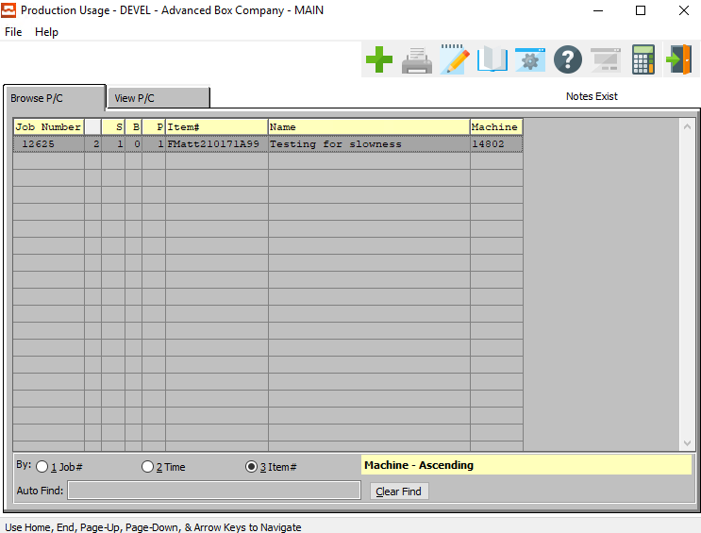

This list can be sorted by Job Number, Time, or Item Number. Alternatively, the user may search for any Production Usage that they wish to use in order to narrow down their selection.

In order to choose the desired Usage from this list, the user may double-click on the desired Job Number line. Alternatively, the user may click on their desired Job Number Line in order to highlight it within the list, then click the ***“View P/C”*** tab at the top of the *Production Usage* screen. Only a highlighted Usage will populate within the detailed *View* screen.

## View P/C

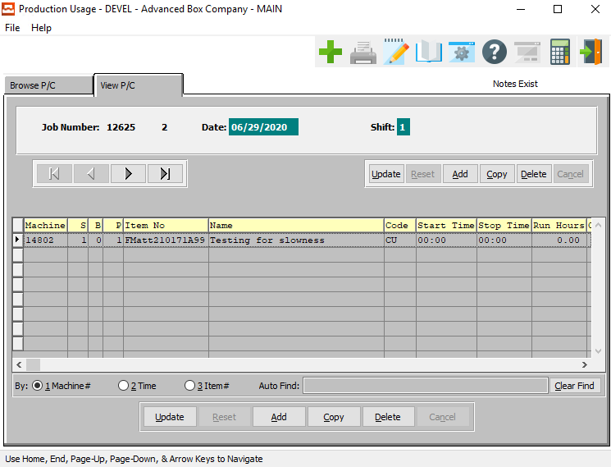

#### UPDATE (Job Information)

To change the currently selected Job Information, simply click the ***“Update***” button under the Job Information section of the screen.

#### ADD (Job Information)

To add a new Job, simply click the ***“Green + Icon”*** button at the top of the Production Usage screen.

Alternatively, click the ***“Add”*** button under the Job Information section of the screen.

#### COPY (Job Information)

Click the ***“Copy”*** button under the Job Information section of the screen to copy information from the currently selected Job.

#### DELETE (Job Information)

To delete the currently selected Job, simply press the ***"D"*** key. Alternatively, click the ***“Delete”*** button under the Job Information section of the screen.

#### NEXT

Press ***"N"*** (Next) to find next Job to view or modify. Alternatively, press the ***“Right Arrow”*** on the screen.

#### PREVIOUS

Press ***"P"*** (Previous) to find previous Job to view or modify. Alternatively, press the ***“Left Arrow”*** on the screen.

#### UPDATE (Machine Transaction)

To change the currently selected Machine Transaction, simply click the ***“Update***” button at the bottom of the screen.

#### ADD (Machine Transaction)

Click the ***“Add”*** button at the bottom of the screen to add a new Machine Transaction.

#### COPY (Machine Transaction)

Click the ***“Copy”*** button to copy information from the currently selected Machine Transaction.

#### DELETE (Machine Transaction)

To delete the currently selected Machine Transaction, simply press the ***"D"*** key. Alternatively, click the ***“Delete”*** button at the bottom of the screen.

### Add/Update Job Information

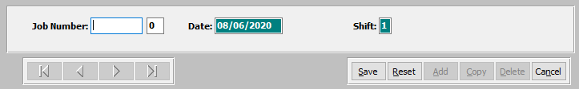

#### SAVE

Click the ***“Save”*** button to save all changes to the current Job Information.

#### RESET

Click the ***“Reset”*** button to reset all fields to their original state.

#### CANCEL

Click the ***“Cancel”*** button to cancel all changes to the Job Information without saving.

### Add/Update Job Information Field Definitions

#### Job Number

The user must now enter the Job Number they wish to base this new Production Usage on. If the user knows the Job Number that they wish to use, they may enter it manually in the *Job Number* field.

Alternatively, the user can press the ***“F1”*** key to choose a number from a list of available Job Information.

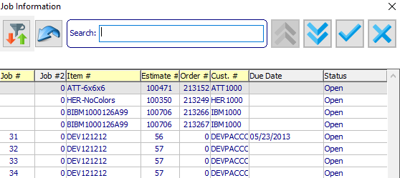

This list can be sorted by Job Number, Item Number, Estimate Number, or Customer Number. Alternatively, the user may search for any Job that they wish to use in order to narrow down their selection.

In order to choose the desired Job Number from this list, the user may double-click on the desired Job line. Alternatively, the user may click on their desired Job Line in order to highlight it within the list, then click the ***“Blue Check Icon”*** button at the top of the *Job Information* screen. Only a highlighted Job will populate within the new Machine Transaction.

#### Job Number: 00

The user may enter the subsequent Job Number, if applicable.

#### Date

Enter the date for this Job Usage. This automatically defaults to the system date, but can be modified by the user as needed.

#### Shift

The user may enter the shift number for this production usage.

### Add/Update Machine Transaction Information

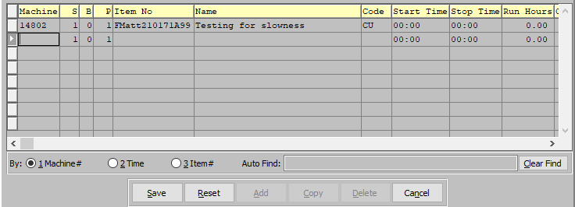

This list can be sorted by Machine Number, Time, or Item Number. Alternatively, the user may search for any Machine Transaction that they wish to use in order to narrow down their selection.

In order to choose the desired Transaction from this list, the user may double-click on the desired Transaction line. Alternatively, the user may click on their desired Transaction Line in order to highlight it within the list, then click the ***“Update”*** or ***“Copy”*** buttons at the bottom of the *View P/C* screen.

#### SAVE

Click the ***“Save”*** button to save all changes to the current Machine Transaction Information.

#### RESET

Click the ***“Reset”*** button to reset all fields to their original state.

#### CANCEL

Click the ***“Cancel”*** button to cancel all changes to the Machine Transaction Information without saving.

### Add/Update Machine Transaction Information Field Definitions

#### Machine

The user must now enter the Machine Code they wish to base this new Transaction on. If the user knows the Machine Code that they wish to use, they may enter it manually in the *Machine Code* field.

Alternatively, the user can press the ***“F1”*** key to choose a Machine Code from a list of available Machine Information.

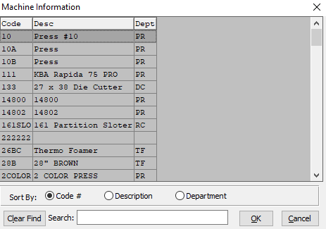

This list can be sorted by Code Number, Description, or Department. Alternatively, the user may search for any Machine that they wish to use in order to narrow down their selection.

In order to choose the desired Machine from this list, the user may double-click on the desired Machine Code line. Alternatively, the user may click on their desired Machine Code Line in order to highlight it within the list, then click the ***“OK”*** button at the bottom of the *Machine Information* screen. Only a highlighted Code will populate within the new Machine Transaction.

#### S/B/P

Enter the sheet form number, blank number, and pass number to which the material cost will be applied.

#### Item No

The Item Number will automatically populate as soon as the user enters or chooses a valid Machine Code. It is not modifiable by the user once chosen.

#### Item Name

The Item Name will automatically populate as soon as the user enters or chooses a valid Machine Code. It is not modifiable by the user once chosen.

#### Code

The user must now enter the Job Code they wish to base this new Transaction on. If the user knows the Job Code that they wish to use, they may enter it manually in the *Code* field.

Alternatively, the user can press the ***“F1”*** key to choose a Job Code from a list of available Job Information.

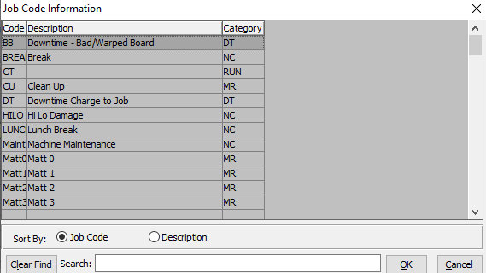

This list can be sorted by Job Code or Description. Alternatively, the user may search for any Job that they wish to use in order to narrow down their selection.

In order to choose the desired Job Code from this list, the user may double-click on the desired Job Code line. Alternatively, the user may click on their desired Job Code Line in order to highlight it within the list, then click the ***“OK”*** button at the bottom of the *Job Information* screen. Only a highlighted Code will populate within the new Machine Transaction.

#### Start Time / Stop Time

Enter the beginning and end time for this Machine Transaction.

#### Run Hours

The number of run hours for this Machine Transaction will automatically calculate as soon as the user enters the *Start Time* and *Stop Time*.

#### Crew Size

Enter the crew size for this Machine Transaction.

#### Quantity

Enter the quantity of items completed during this Machine Transaction.

#### Waste

Enter the total quantity of the materials wasted during this Machine Transaction.

#### Complete

To mark this Job as complete the user should enter a *“yes”* in this field. If this job has not been completed during the currently selected machine transaction, the user should enter a *“no”* in this field.

# **Floor Reporting at Machine [DF]**

## Browse P/C

The *Production Usage* screen is located in the following Menu Path: Data Collection -> Floor Reporting at Machine. Alternatively, the user can quickly get to this screen using Hot Key combination: ***[“D” – “F”]***.

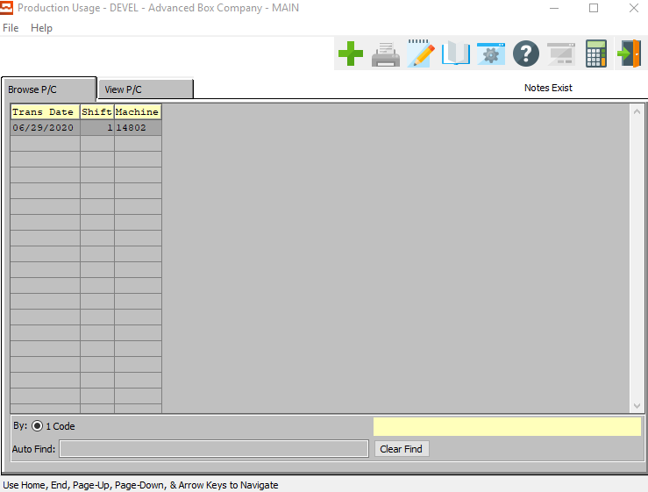

This list can only be sorted by Machine Code. Alternatively, the user may search for any Machine Transaction that they wish to use in order to narrow down their selection.

In order to choose the desired Machine Transaction from this list, the user may double-click on the desired Transaction Date line. Alternatively, the user may click on their desired Date Line in order to highlight it within the list, then click the ***“View P/C”*** tab at the top of the *Production Usage* screen. Only a highlighted Machine Transaction will populate within the detailed *View* screen.

## View P/C

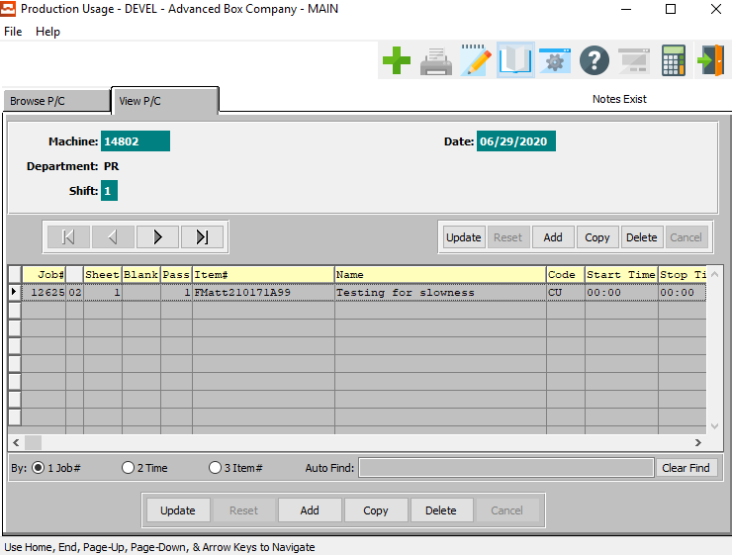

#### UPDATE (Machine Information)

To change the currently selected Machine Information, simply click the ***“Update***” button under the Machine Information section of the screen.

#### ADD (Machine Information)

To add a new Machine, simply click the ***“Green + Icon”*** button at the top of the Production Usage screen.

Alternatively, click the ***“Add”*** button under the Machine Information section of the screen.

#### COPY (Machine Information)

Click the ***“Copy”*** button under the Machine Information section of the screen to copy information from the currently selected Machine.

#### DELETE (Machine Information)

To delete the currently selected Machine, simply press the ***"D"*** key. Alternatively, click the ***“Delete”*** button under the Machine Information section of the screen.

#### NEXT

Press ***"N"*** (Next) to find next Machine to view or modify. Alternatively, press the ***“Right Arrow”*** on the screen.

#### PREVIOUS

Press ***"P"*** (Previous) to find previous Machine to view or modify. Alternatively, press the ***“Left Arrow”*** on the screen.

#### UPDATE (Machine Transaction)

To change the currently selected Machine Transaction, simply click the ***“Update***” button at the bottom of the screen.

#### ADD (Machine Transaction)

Click the ***“Add”*** button at the bottom of the screen to add a new Machine Transaction.

#### COPY (Machine Transaction)

Click the ***“Copy”*** button to copy information from the currently selected Machine Transaction.

#### DELETE (Machine Transaction)

To delete the currently selected Machine Transaction, simply press the ***"D"*** key. Alternatively, click the ***“Delete”*** button at the bottom of the screen.

### Add/Update Machine Information

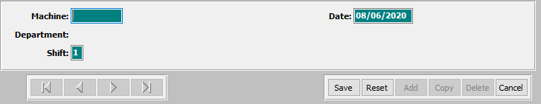

#### SAVE

Click the ***“Save”*** button to save all changes to the current Job Information.

#### RESET

Click the ***“Reset”*** button to reset all fields to their original state.

#### CANCEL

Click the ***“Cancel”*** button to cancel all changes to the Job Information without saving.

### Add/Update Machine Information Field Definitions

#### Machine Code

The user must now enter the machine Code they wish to base this new Production Usage on. If the user knows the Machine Code that they wish to use, they may enter it manually in the *Machine* field.

Alternatively, the user can press the ***“F1”*** key to choose a number from a list of available Machine Information.

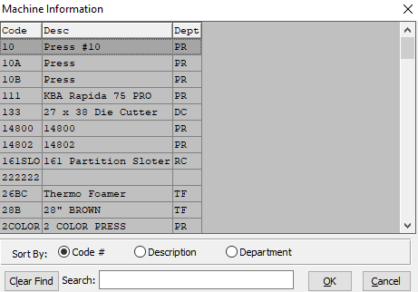

This list can be sorted by Machine Code Number, Machine Description, or Department. Alternatively, the user may search for any Machine that they wish to use in order to narrow down their selection.

In order to choose the desired machine Code from this list, the user may double-click on the desired Code line. Alternatively, the user may click on their desired Code Line in order to highlight it within the list, then click the ***“Okay”*** button at the top of the *Machine Information* screen. Only a highlighted Machine will populate within the new Machine Transaction.

#### Date

Enter the date for this Job Usage. This automatically defaults to the system date, but can be modified by the user as needed.

#### Shift

The user may enter the shift number for this production usage.

### Add/Update Machine Transaction Information

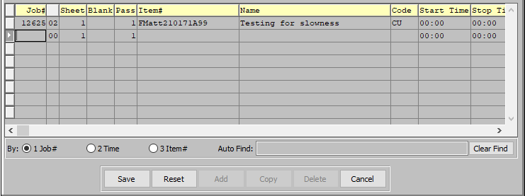

This list can be sorted by Job Number, Time, or Item Number. Alternatively, the user may search for any Machine Transaction that they wish to use in order to narrow down their selection.

In order to choose the desired Transaction from this list, the user may double-click on the desired Transaction line. Alternatively, the user may click on their desired Transaction Line in order to highlight it within the list, then click the ***“Update”*** or ***“Copy”*** buttons at the bottom of the *View P/C* screen.

#### SAVE

Click the ***“Save”*** button to save all changes to the current Machine Transaction Information.

#### RESET

Click the ***“Reset”*** button to reset all fields to their original state.

#### CANCEL

Click the ***“Cancel”*** button to cancel all changes to the Machine Transaction Information without saving.

### Add/Update Machine Transaction Information Field Definitions

#### Job Number

The user must now enter the Job Number they wish to base this new Production Usage on. If the user knows the Job Number that they wish to use, they may enter it manually in the *Job Number* field.

Alternatively, the user can press the ***“F1”*** key to choose a number from a list of available Job Information.

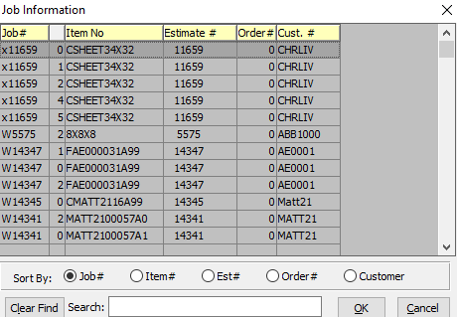

This list can be sorted by Job Number, Item Number, Estimate Number, or Customer Number. Alternatively, the user may search for any Job that they wish to use in order to narrow down their selection.

In order to choose the desired Job Number from this list, the user may double-click on the desired Job line. Alternatively, the user may click on their desired Job Line in order to highlight it within the list, then click the ***“Blue Check Icon”*** button at the top of the *Job Information* screen. Only a highlighted Job will populate within the new Machine Transaction.

#### Job Number: 00

The user may enter the subsequent Job Number, if applicable.

#### Sheet / Blank / Pass

Enter the sheet form number, blank number, and pass number to which the material cost will be applied.

#### Item #

The Item Number will automatically populate as soon as the user enters or chooses a valid Machine Code. It is not modifiable by the user once chosen.

#### Item Name

The Item Name will automatically populate as soon as the user enters or chooses a valid Machine Code. It is not modifiable by the user once chosen.

#### Code

The user must now enter the Job Code they wish to base this new Transaction on. If the user knows the Job Code that they wish to use, they may enter it manually in the *Code* field.

Alternatively, the user can press the ***“F1”*** key to choose a Job Code from a list of available Job Information.



This list can be sorted by Job Code or Description. Alternatively, the user may search for any Job that they wish to use in order to narrow down their selection.

In order to choose the desired Job Code from this list, the user may double-click on the desired Job Code line. Alternatively, the user may click on their desired Job Code Line in order to highlight it within the list, then click the ***“OK”*** button at the bottom of the *Job Information* screen. Only a highlighted Code will populate within the new Machine Transaction.

#### Start Time / Stop Time

Enter the beginning and end time for this Machine Transaction.

#### Run Hours

The number of run hours for this Machine Transaction will automatically calculate as soon as the user enters the *Start Time* and *Stop Time*.

#### Crew Size

Enter the crew size for this Machine Transaction.

#### Quantity

Enter the quantity of items completed during this Machine Transaction.

#### Waste

Enter the total quantity of the materials wasted during this Machine Transaction.

#### Complete

To mark this Job as complete the user should enter a *“yes”* in this field. If this job has not been completed during the currently selected machine transaction, the user should enter a *“no”* in this field.

# **Labor/Miscellaneous Material Costs [DL]**

## Miscellaneous Entry/Maintenance [DL1]

### Material / Labor

The *Enter Miscellaneous Materials for Posting to Job* screen is located in the following Menu Path: Data Collection -> Labor/Misc. Materials Costs -> Miscellaneous Entry/Maintenance. Alternatively, the user can quickly get to this screen using the Hot Key combination: ***[“D” – “L” – “1”]***.

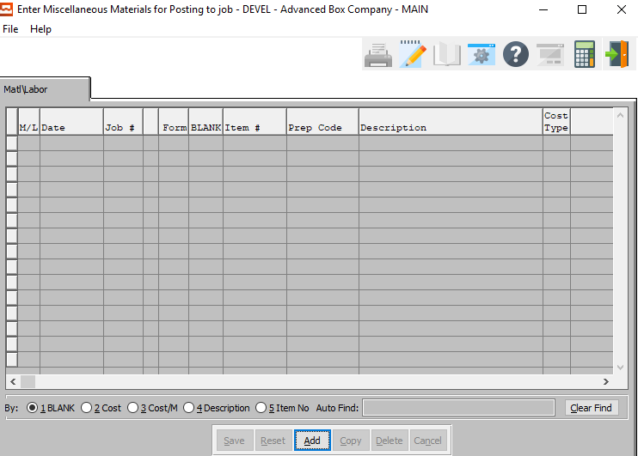

This list can be sorted by Blank Number, Cost, Cost/M, Description, or Item Number. Alternatively, the user may search for any Miscellaneous Material that they wish to use in order to narrow down their selection. In order to choose the desired material from this list, the user may double-click on the desired Material line.

#### ADD

Click the ***“Add”*** button at the bottom of the screen to add a new Miscellaneous Material.

#### COPY

Click the ***“Copy”*** button to copy information from the currently selected Miscellaneous Material.

#### DELETE

To delete the currently selected Miscellaneous Material, simply press the ***"D"*** key. Alternatively, click the ***“Delete”*** button at the bottom of the screen.

### Add Material/Labor

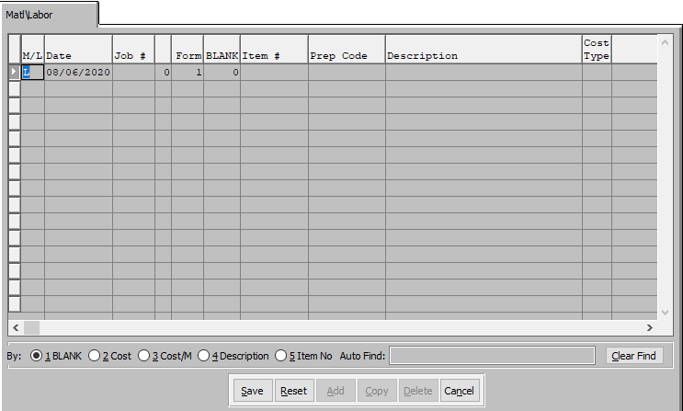

#### SAVE

Click the ***“Save”*** button to save all changes to the current Miscellaneous Material.

#### RESET

Click the ***“Reset”*** button to reset all fields to their original state.

#### CANCEL

Click the ***“Cancel”*** button to cancel all changes to the Miscellaneous Material without saving.

### Add Material Labor Field Definitions

#### (M/L) Material/Labor

If this Miscellaneous Item is a *Material* item, the user should enter a ***“M”*** in this field. Alternatively, if this Miscellaneous Item is a *Labor* item, the user should enter a ***“L”*** in this field. Any character other than and ***“M”*** or ***“L”*** is not a valid entry.

#### Date

Enter the date for this Miscellaneous Item entry. This defaults to the system date, but can be modified by the user as necessary.

#### Job #

The user must now enter the Job Number they wish to base this new Miscellaneous Item on. If the user knows the Job Number that they wish to use, they may enter it manually in the *Job #* field.

Alternatively, the user can press the ***“F1”*** key to choose a Job Number from a list of available Job Information.



This list can be sorted by Job Number, Item Number, Estimate Number, Order Number, or Customer. Alternatively, the user may search for any Job that they wish to use in order to narrow down their selection.

In order to choose the desired Job Number from this list, the user may double-click on the desired Job line. Alternatively, the user may click on their desired Job Line in order to highlight it within the list, then click the ***“OK”*** button at the bottom of the *Job Information* screen. Only a highlighted Job will populate within the new Miscellaneous Item.

#### Form / Blank

Enter the Form Number and Blank Number for this Miscellaneous Item.

#### Item #

Enter valid item number from Finished Goods or Raw Materials files. Optionally, press “***F1”*** to search, or the ***“Page Up”*** / ***“Page Down”*** keys to scroll through the Item file. Press the “***Enter***” key to accept the Item displayed on the screen.

As soon as the user makes their selection, or finishes manually entering a valid Item Number, many subsequent fields will automatically fill with necessary information.

#### Prep Code

Enter a code for this preparation charge. Examples of preparation charges include Lock up cost per item, Step and Repeat per number up, Die Cost per Square Inch, Stamping Dies, Embossing Dies, Plates, Rerun Plate cost, Rerun Die Hours, Negatives and Sample Making.

#### Description

The Item Name/Description field will automatically populate as soon as the user enters or chooses a valid item number.

#### Cost Type

Enter the material cost type for this raw material. General ledger account numbers for the raw material asset account, consumption expense account and purchase price variance account are assigned by material cost types which interface with job costing and the general ledger.

Debit and credits are automatically recorded via receipts for purchases, actual production postings and adjustments. The work-in-process inventory general ledger account numbers are set up in the job cost product line file so that offsetting debits are posted when raw materials are issued to the job.

#### Cost

This is the cost of the currently selected item. This field will automatically populate as soon as the user enters of chooses a valid item number.

#### Cost/M

Enter the cost per item.

## Miscellaneous Edit List [DL2]

The *Miscellaneous Edit Report* screen is located in the following Menu Path: Data Collection -> Labor/Misc. Material Costs -> Miscellaneous Edit List. Alternatively, the user can quickly get to this screen using the Hot Key combination: ***[“D” – “L” – “2”]***.

### Selection Parameters

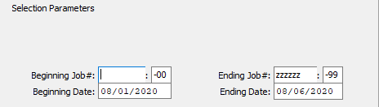

#### Beginning Job # / Ending Job #

Enter the beginning and ending Job Number to run the Miscellaneous Edit List for.

#### Beginning Job #: 00 / Ending Job #: 00

Enter the beginning and ending Subsequent Job Number to run the Miscellaneous Edit List for.

#### Beginning Date / Ending Date

Enter the beginning and ending Job Date to run the Miscellaneous Edit List for.

### Output Destination

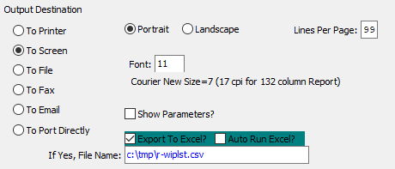

#### Destination Choice

To choose the destination where the document should be printed, please make sure that desired output destination choice bubble is toggled.

#### Layout Choice

To choose the preferred layout of Landscape vs. Portrait, please make sure the desired option choice bubbled is toggled.

#### Lines Per Page

Lines per page on the report when printing.

#### Font

Enter the font number to use with this report (Font 11 is default).

#### Show Parameters? – Toggle Box

To show parameters, make sure that the toggle box is ‘ticked’ with a checkmark.

#### Export to Excel? – Toggle Box

To export the printed file to an excel document, make sure that the Export to Excel toggle box is checked.

#### Auto Run Excel? – Toggle Box

To automatically open the new excel document, make sure that the Auto Run Excel toggle box is checked.

#### If Yes, File Name

If exporting the file to Excel, enter the desired file name.

## Transfer Misc. Costs to Job [DL3]

The *Transfer Misc. Costs to Job* program is located in the following Menu Path: Data Collection -> Labor/Misc. Material Costs -> Transfer Misc. Costs to Job. Alternatively, the user can quickly get to this screen using the Hot Key combination: ***[“D” – “L” – “2”]***.

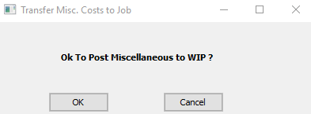

This program will transfer all of the currently active and un-transferred Miscellaneous Labor and Item costs to their designated jobs. This can be done very simply by clicking on the ***“Okay”*** button.

# **WIP Hours Preposted Edit List [DW]**

The *WIP Edit List* screen is located in the following Menu Path: Data Collection -> WIP hours Preposted Edit List. Alternatively, the user can quickly get to this screen using Hot Key combination: ***[“D” – “W”]***.

## Selection Parameters

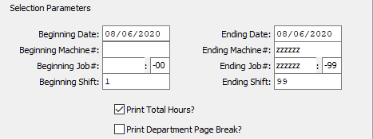

#### Beginning Date / Ending Date

Enter the beginning and ending Date to run the Work in Process Edit List for.

#### Beginning Machine # / Ending Machine #

Enter the beginning and ending Machine Number to run the Work in Process Edit List for.

#### Beginning Job # / Ending Job #

Enter the beginning and ending Job Number to run the Work in Process Edit List for.

#### Beginning Job #: 00 / Ending Job #: 00

Enter the beginning and ending Subsequent Job Number to run the Work in Process Edit List for.

#### Beginning Shift / Ending Shift

Enter the beginning and ending Shift number to XXX for.

#### Print Total Hours? – Toggle Box

To print the total number of calculated hours on the edit list report, make sure that the Print Total Hours toggle box is checked.

#### Print Department Page Break? – Toggle Box

To print page breaks on the report based upon different departments, make sure that the Print Department Page Break toggle box is checked.

## Output Destination

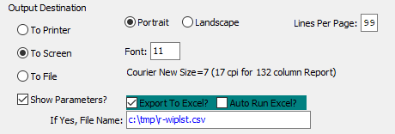

#### Destination Choice

To choose the destination where the document should be printed, please make sure that desired output destination choice bubble is toggled.

#### Layout Choice

To choose the preferred layout of Landscape vs. Portrait, please make sure the desired option choice bubbled is toggled.

#### Lines Per Page

Lines per page on the report when printing.

#### Font

Enter the font number to use with this report (Font 11 is default).

#### Show Parameters? – Toggle Box

To show parameters, make sure that the toggle box is ‘ticked’ with a checkmark.

#### Export to Excel? – Toggle Box

To export the printed file to an excel document, make sure that the Export to Excel toggle box is checked.

#### Auto Run Excel? – Toggle Box

To automatically open the new excel document, make sure that the Auto Run Excel toggle box is checked.

#### If Yes, File Name

If exporting the file to Excel, enter the desired file name.

# **Transfer WIP to Job Cost [DT]**

The *Transfer WIP to Job Cost* screen is located in the following Menu Path: Data Collection -> Transfer WIP to Job Cost. Alternatively, the user can quickly get to this screen using the Hot Key combination: ***[“D” – “T”]***.

## Selection Parameters

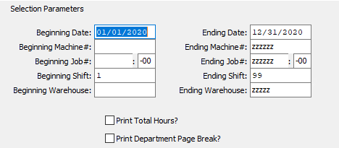

#### Beginning Date / Ending Date

Enter the beginning and ending Date to transfer works in process for.

#### Beginning Machine # / Ending Machine #

Enter the beginning and ending Machine Number to transfer works in process for.

#### Beginning Job # / Ending Job #

Enter the beginning and ending Job Number to transfer works in process for.

#### Beginning Job #: 00 / Ending Job #: 00

Enter the beginning and ending Subsequent Job Number to transfer works in process for.

#### Beginning Shift / Ending Shift

Enter the beginning and ending Shift Number to transfer works in process for.

#### Beginning Warehouse / Ending Warehouse

Enter the beginning and ending Warehouse Code to transfer works in process for.

#### Print Total Hours? – Toggle Box

To print the total number of calculated hours on the edit list report, make sure that the Print Total Hours toggle box is checked.

#### Print Department Page Break? – Toggle Box

To print page breaks on the report based upon different departments, make sure that the Print Department Page Break toggle box is checked.

## Output Destination



#### Destination Choice

To choose the destination where the document should be printed, please make sure that desired output destination choice bubble is toggled.

#### Layout Choice

To choose the preferred layout of Landscape vs. Portrait, please make sure the desired option choice bubbled is toggled.

#### Lines Per Page

Lines per page on the report when printing.

#### Font

Enter the font number to use with this report (Font 11 is default).

#### Show Parameters? – Toggle Box

To show parameters, make sure that the toggle box is ‘ticked’ with a checkmark.

#### Export to Excel? – Toggle Box

To export the printed file to an excel document, make sure that the Export to Excel toggle box is checked.

#### Auto Run Excel? – Toggle Box

To automatically open the new excel document, make sure that the Auto Run Excel toggle box is checked.

#### If Yes, File Name

If exporting the file to Excel, enter the desired file name.

# **Reports for Data Collection [DR]**

## Machine Efficiency [DR1]

The *Machine Efficiency Report* shows comparison of actual versus estimated standard hours, speed and waste displaying efficiency and utilization of the machine.

The report is useful to see what machines are losing money, what machines may need to be replaced and also as a tool to upgrade your machine standards for make ready, run speeds and waste standards in the machine file. The [DR3] report provides more details per job number.

The print selection allows limiting the report by machine department, machine code and any date range and may be sorted by department, industry or shift. The report may be output computer screen, printer, fax, email or directly text file or to an excel format.

The *Machine Efficiency Report* screen is located in the following Menu Path: Data Collection -> Reports for Data Collection -> Machine Efficiency. Alternatively, the user can quickly get to this screen using the Hot Key combination: ***[“D” – “R” – “1”]***.

The Actual Hours in this report includes Charged Downtime.

### Selection Parameters

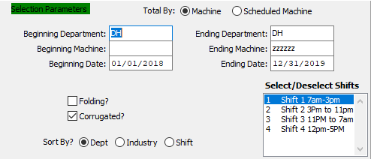

#### Total By (Choice)

To choose the preferred efficiency total option of Machine vs. Scheduled Machine, please make sure the desired option choice bubble is toggled.

#### Beginning Department / Ending Department

Enter the beginning and ending Department Code to run the Machine Efficiency report for.

#### Beginning Machine / Ending Machine

Enter the beginning and ending Machine Code to run the Machine Efficiency report for.

#### Beginning Date / Ending Date

Enter the beginning and ending Date to run the Machine Efficiency report for.

#### Folding? – Toggle Box

To include folding materials in the Machine Efficiency report, make sure that the Folding toggle box is checked.

#### Corrugated? – Toggle Box

To include corrugated materials in the Machine Efficiency report, make sure that the Corrugated toggle box is checked.

#### Sort By? (Choice)

To choose the preferred sorting method, please make sure the desired option choice bubble is toggled.

#### Select/Deselect Shifts

The user may select which shifts they wish to include in the current Work in Process transfer. To select multiple shifts, press the ***“Control”*** button while clicking the desired shifts within the available shift list. Selected shifts will be highlighted, and only highlighted shifts will be included in the Work in Process transfer. To deselect shifts, press the ***“Control”*** button while clicking already-highlighted selections.

### Available and Selected Columns

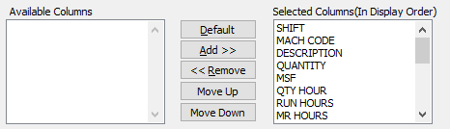

#### Available Columns

The user may choose which columns they wish to have on the report printout. As the user selects their choices, they will appear on the ‘*Selected Columns’* list.

#### Selected Columns (In Display Order)

The columns that the user has chosen from the ‘*Available Columns’* list. The order that these columns are displayed in here is the order in which they will print on the report.

#### Default

Click the ***“Default****”* button to sort the ‘*Selected Columns’* list by the default system parameters.

#### Add >>

Click on the selected item from the ‘*Available Columns’* list to highlight it, then click the ***“Add”*** button to add the selected column to the ‘*Selected Columns’* list.

#### << Remove

Click on the selected item from the ‘*Selected Columns’* list to highlight it, then click the ***“Remove”*** button to remove the selected column to the ‘*Selected Columns’* list.

#### Move Up

Within the ‘*Selected Columns’* list, the user may choose the order they wish the selected columns to print in. In order to change the order of the columns, the user can click on a selection to highlight it. By then clicking the ***“Move Up***” button, the user can change its position on the report.

#### Move Down

Within the ‘*Selected Columns’* list, the user may choose the order they wish the selected columns to print in. In order to change the order of the columns, the user can click on a selection to highlight it. By then clicking the ***“Move Down***” button, the user can change its position on the report.

### Output Destination

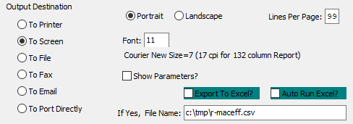

#### Destination Choice

To choose the destination where the document should be printed, please make sure that desired output destination choice bubble is toggled.

#### Layout Choice

To choose the preferred layout of Landscape vs. Portrait, please make sure the desired option choice bubbled is toggled.

#### Lines Per Page

Lines per page on the report when printing.

#### Font

Enter the font number to use with this report (Font 11 is default).

#### Show Parameters? – Toggle Box

To show parameters, make sure that the toggle box is ‘ticked’ with a checkmark.

#### Export to Excel? – Toggle Box

To export the printed file to an excel document, make sure that the Export to Excel toggle box is checked.

#### Auto Run Excel? – Toggle Box

To automatically open the new excel document, make sure that the Auto Run Excel toggle box is checked.

#### If Yes, File Name

If exporting the file to Excel, enter the desired file name.

## Machine Backlog Analysis [DR2]

The *Machine Backlog* report shows machine hour backlog for each day, while printing the details of each job for the day including hours required and hours remaining.

The visual scheduling software provides far greater visual and reporting options, but this report can be used when the scheduling module is not purchased.

The print selection allows limited the report by machine department, machine code up to a specific start date or due date. The report also has an option to print either the machine description or customer name. The report may be output computer screen, printer, fax, email or directly text file or to an excel format.

The *Machine Backlog* screen is located in the following Menu Path: Data Collection -> Reports for Data Collection -> Machine Backlog Analysis. Alternatively, the user can quickly get to this screen using the Hot Key combination: ***[“D” – “R” – “2”]***.

### Selection Parameters

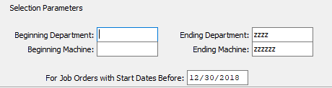

#### Beginning Department / Ending Department

Enter the beginning and ending Department Code to run the Machine Backlog Analysis report for.

#### Beginning Machine / Ending Machine

Enter the beginning and ending Machine Code to run the Machine Backlog Analysis report for.

#### For Job Orders with Start Dates Before

The date entered here will be the last date of the report. Any job orders after that date will be left off of the report.

### Available and Selected Columns

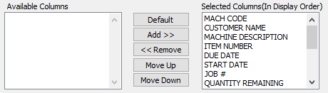

#### Available Columns

The user may choose which columns they wish to have on the report printout. As the user selects their choices, they will appear on the ‘*Selected Columns’* list.

#### Selected Columns (In Display Order)

The columns that the user has chosen from the ‘*Available Columns’* list. The order that these columns are displayed in here is the order in which they will print on the report.

#### Default

Click the ***“Default****”* button to sort the ‘*Selected Columns’* list by the default system parameters.

#### Add >>

Click on the selected item from the ‘*Available Columns’* list to highlight it, then click the ***“Add”*** button to add the selected column to the ‘*Selected Columns’* list.

#### << Remove

Click on the selected item from the ‘*Selected Columns’* list to highlight it, then click the ***“Remove”*** button to remove the selected column to the ‘*Selected Columns’* list.

#### Move Up

Within the ‘*Selected Columns’* list, the user may choose the order they wish the selected columns to print in. In order to change the order of the columns, the user can click on a selection to highlight it. By then clicking the ***“Move Up***” button, the user can change its position on the report.

#### Move Down

Within the ‘*Selected Columns’* list, the user may choose the order they wish the selected columns to print in. In order to change the order of the columns, the user can click on a selection to highlight it. By then clicking the ***“Move Down***” button, the user can change its position on the report.

### Output Destination

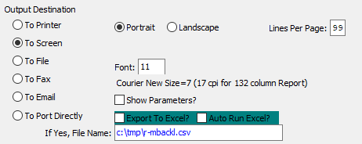

#### Destination Choice

To choose the destination where the document should be printed, please make sure that desired output destination choice bubble is toggled.

#### Layout Choice

To choose the preferred layout of Landscape vs. Portrait, please make sure the desired option choice bubbled is toggled.

#### Lines Per Page

Lines per page on the report when printing.

#### Font

Enter the font number to use with this report (Font 11 is default).

#### Show Parameters? – Toggle Box

To show parameters, make sure that the toggle box is ‘ticked’ with a checkmark.

#### Export to Excel? – Toggle Box

To export the printed file to an excel document, make sure that the Export to Excel toggle box is checked.

#### Auto Run Excel? – Toggle Box

To automatically open the new excel document, make sure that the Auto Run Excel toggle box is checked.

## Production by Department [DR3]

The machine productivity by department shows comparison of actual versus estimated standard hours, speed and waste displaying efficiency of job and utilization of the machine on a job by job detail. The [DR1] report can be used as a summary by machine, then this report can further pinpoint problems.

The report is useful to see what jobs are losing money, what machines may need to be replaced and also as a tool to upgrade your machine standards for make ready, run speeds and waste standards in the machine file. The report may be output computer screen, printer, fax, email or directly text file or to an excel format.

The print selection allows limited the report by machine department, machine code and any date range and may be sorted by department, industry or shift.

The *Productivity by Department* screen is located in the following Menu Path: Data Collection -> Reports for Data Collection -> Production by Department. Alternatively, the user can quickly get to this screen using the Hot Key combination: ***[“D” – “R” – “3”]***.

The Actual Hours in this report excludes Charged Downtime. This report prints only one (1) decimal position, which is rounded to fit data, thus percentages are higher.

This report must allocate Machine Rate standard hours by shift. The calculation takes the total actual Machine Rate hours per shift divided by total Machine Rate hours.

### Selection Parameters

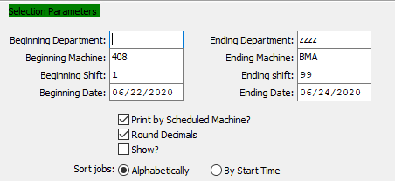

#### Beginning Department / Ending Department

Enter the beginning and ending Department Code to run the Production by Department report for.

#### Beginning Machine / Ending Machine

Enter the beginning and ending Machine Code to run the Production by Department report for.

#### Beginning Shift / Ending Shift

Enter the beginning and ending Shift Number to run the Production by Department report for.

#### Beginning Date / Ending Date

Enter the beginning and ending Date to run the Production by Department report for.

#### Print by Scheduled Machine? – Toggle Box

To print the report by scheduled machine, make sure that this toggle box is checked.

#### Round Decimals – Toggle Box

To round all hour count decimals within the selected parameters, make sure that the Round Decimals toggle box is checked.

#### Show? – Toggle Box

To show hour count decimals on the report, make sure that the Show toggle box is checked.

#### Sort Jobs (Choice)

To choose the preferred sorting methods of Alphabetically vs. By Start Time, please make sure the desired option choice bubble is toggled.

### Available and Selected Columns

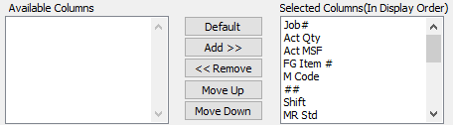

#### Available Columns

The user may choose which columns they wish to have on the report printout. As the user selects their choices, they will appear on the ‘*Selected Columns’* list.

#### Selected Columns (In Display Order)

The columns that the user has chosen from the ‘*Available Columns’* list. The order that these columns are displayed in here is the order in which they will print on the report.

#### Default

Click the ***“Default****”* button to sort the ‘*Selected Columns’* list by the default system parameters.

#### Add >>

Click on the selected item from the ‘*Available Columns’* list to highlight it, then click the ***“Add”*** button to add the selected column to the ‘*Selected Columns’* list.

#### << Remove

Click on the selected item from the ‘*Selected Columns’* list to highlight it, then click the ***“Remove”*** button to remove the selected column to the ‘*Selected Columns’* list.

#### Move Up

Within the ‘*Selected Columns’* list, the user may choose the order they wish the selected columns to print in. In order to change the order of the columns, the user can click on a selection to highlight it. By then clicking the ***“Move Up***” button, the user can change its position on the report.

#### Move Down

Within the ‘*Selected Columns’* list, the user may choose the order they wish the selected columns to print in. In order to change the order of the columns, the user can click on a selection to highlight it. By then clicking the ***“Move Down***” button, the user can change its position on the report.

### Output Destination

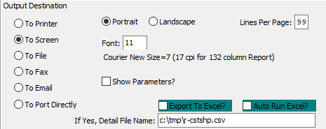

#### Destination Choice

To choose the destination where the document should be printed, please make sure that desired output destination choice bubble is toggled.

#### Layout Choice

To choose the preferred layout of Landscape vs. Portrait, please make sure the desired option choice bubbled is toggled.

#### Lines Per Page

Lines per page on the report when printing.

#### Font

Enter the font number to use with this report (Font 11 is default).

#### Show Parameters? – Toggle Box

To show parameters, make sure that the toggle box is ‘ticked’ with a checkmark.

#### Export to Excel? – Toggle Box

To export the printed file to an excel document, make sure that the Export to Excel toggle box is checked.

#### Auto Run Excel? – Toggle Box

To automatically open the new excel document, make sure that the Auto Run Excel toggle box is checked.

#### If Yes, File Name

If exporting the file to Excel, enter the desired file name.

## Production by Machine [DR4]

The machine productivity by department shows comparison of actual versus estimated standard hours, speed and waste displaying efficiency of job and utilization of the machine on a job by job detail. The [DR1] report can be used as a summary by machine, then this report can further pinpoint problems.

The report is useful to see what jobs are losing money, what machines may need to be replaced and also as a tool to upgrade your machine standards for make ready, run speeds and waste standards in the machine file. The report may be output computer screen, printer, fax, email or directly text file or to an excel format.

The print selection allows limited the report by machine department, machine code and any date range and may be sorted by department, industry or shift.

The *Production by Machine* screen is located in the following Menu Path: Data Collection -> Reports for Data Collection -> Production by Machine. Alternatively, the user can quickly get to this screen using the Hot Key combination: ***[“D” – “R” – “4”]***.

### Selection Parameters

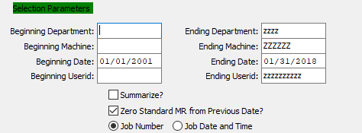

#### Beginning Department / Ending Department

Enter the beginning and ending Department Code to run the Production by Machine report for.

#### Beginning Machine / Ending Machine

Enter the beginning and ending Machine Code to run the Production by Machine report for.

#### Beginning Date / Ending Date

Enter the beginning and ending Date to run the Production by Machine report for.

#### Beginning User ID / Ending User ID

Enter the beginning and ending User ID to run the Production by Machine report for.

#### Summarize? – Toggle Box

To print a summarization to the Production by Machine report, make sure that the Summarize toggle box is checked.

#### Zero Standard MR from Previous Date? – Toggle Box

To zero-out the standard machine rate, make sure that this toggle box is checked.

#### Sort Method (Choice)

To choose the preferred sorting method of Job Number vs. Job Date and Time, please make sure the desired option choice bubble is toggled.

### Available and Selected Columns

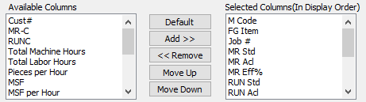

#### Available Columns

The user may choose which columns they wish to have on the report printout. As the user selects their choices, they will appear on the ‘*Selected Columns’* list.

#### Selected Columns (In Display Order)

The columns that the user has chosen from the ‘*Available Columns’* list. The order that these columns are displayed in here is the order in which they will print on the report.

#### Default

Click the ***“Default****”* button to sort the ‘*Selected Columns’* list by the default system parameters.

#### Add >>

Click on the selected item from the ‘*Available Columns’* list to highlight it, then click the ***“Add”*** button to add the selected column to the ‘*Selected Columns’* list.

#### << Remove

Click on the selected item from the ‘*Selected Columns’* list to highlight it, then click the ***“Remove”*** button to remove the selected column to the ‘*Selected Columns’* list.

#### Move Up

Within the ‘*Selected Columns’* list, the user may choose the order they wish the selected columns to print in. In order to change the order of the columns, the user can click on a selection to highlight it. By then clicking the ***“Move Up***” button, the user can change its position on the report.

#### Move Down

Within the ‘*Selected Columns’* list, the user may choose the order they wish the selected columns to print in. In order to change the order of the columns, the user can click on a selection to highlight it. By then clicking the ***“Move Down***” button, the user can change its position on the report.

### Output Destination

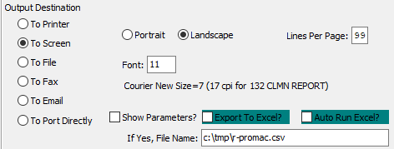

#### Destination Choice

To choose the destination where the document should be printed, please make sure that desired output destination choice bubble is toggled.

#### Layout Choice

To choose the preferred layout of Landscape vs. Portrait, please make sure the desired option choice bubbled is toggled.

#### Lines Per Page

Lines per page on the report when printing.

#### Font

Enter the font number to use with this report (Font 11 is default).

#### Show Parameters? – Toggle Box

To show parameters, make sure that the toggle box is ‘ticked’ with a checkmark.

#### Export to Excel? – Toggle Box

To export the printed file to an excel document, make sure that the Export to Excel toggle box is checked.

#### Auto Run Excel? – Toggle Box

To automatically open the new excel document, make sure that the Auto Run Excel toggle box is checked.

#### If Yes, File Name

If exporting the file to Excel, enter the desired file name.

## Data Collection Waste by Department [DR5]

The waste report shows machine and department productivity via a comparison of actual versus estimated standard hours, speed and waste displaying efficiency of job and utilization of the machine on a job by job detail. The [DR1] report can be used as a summary by machine, then this report can further pinpoint problems.

The report is useful to see what jobs are losing money, what machines may need to be replaced and also as a tool to upgrade your machine standards for make ready, run speeds and waste standards in the machine file. The report may be output computer screen, printer, fax, email or directly text file or to an excel format.

The print selection allows limited the report by machine department, machine code and any date range and may be sorted by department, industry or shift.

The *Departmental Waste Report* screen is located in the following Menu Path: Data Collection -> Reports for Data Collection -> Data Collection Waste By. Alternatively, the user can quickly get to this screen using the Hot Key combination: ***[“D” – “R” – “5”]***.

### Selection Parameters

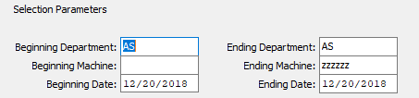

#### Beginning Department / Ending Department

Enter the beginning and ending Department Code to run the Data Collection Waste report for.

#### Beginning Machine / Ending Machine

Enter the beginning and ending Machine Code to run the Data Collection Waste report for.

#### Beginning Date / Ending Date

Enter the beginning and ending Date to run the Data Collection Waste report for.

### Available and Selected Columns

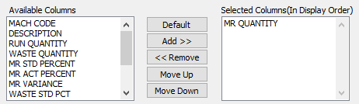

#### Available Columns

The user may choose which columns they wish to have on the report printout. As the user selects their choices, they will appear on the ‘*Selected Columns’* list.

#### Selected Columns (In Display Order)

The columns that the user has chosen from the ‘*Available Columns’* list. The order that these columns are displayed in here is the order in which they will print on the report.

#### Default

Click the ***“Default****”* button to sort the ‘*Selected Columns’* list by the default system parameters.

#### Add >>

Click on the selected item from the ‘*Available Columns’* list to highlight it, then click the ***“Add”*** button to add the selected column to the ‘*Selected Columns’* list.

#### << Remove

Click on the selected item from the ‘*Selected Columns’* list to highlight it, then click the ***“Remove”*** button to remove the selected column to the ‘*Selected Columns’* list.

#### Move Up

Within the ‘*Selected Columns’* list, the user may choose the order they wish the selected columns to print in. In order to change the order of the columns, the user can click on a selection to highlight it. By then clicking the ***“Move Up***” button, the user can change its position on the report.

#### Move Down

Within the ‘*Selected Columns’* list, the user may choose the order they wish the selected columns to print in. In order to change the order of the columns, the user can click on a selection to highlight it. By then clicking the ***“Move Down***” button, the user can change its position on the report.

### Output Destination

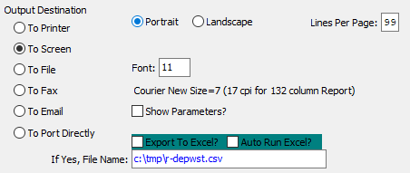

#### Destination Choice

To choose the destination where the document should be printed, please make sure that desired output destination choice bubble is toggled.

#### Layout Choice

To choose the preferred layout of Landscape vs. Portrait, please make sure the desired option choice bubbled is toggled.

#### Lines Per Page

Lines per page on the report when printing.

#### Font

Enter the font number to use with this report (Font 11 is default).

#### Show Parameters? – Toggle Box

To show parameters, make sure that the toggle box is ‘ticked’ with a checkmark.

#### Export to Excel? – Toggle Box

To export the printed file to an excel document, make sure that the Export to Excel toggle box is checked.

#### Auto Run Excel? – Toggle Box

To automatically open the new excel document, make sure that the Auto Run Excel toggle box is checked.

#### If Yes, File Name

If exporting the file to Excel, enter the desired file name.

## Labor Hours vs. Estimated [DR6]

The labor hours versus estimate hours shows comparison of actual hours posted to production versus estimated standard hours without any run speed or waste reporting. The report is useful to see what machines are losing money, what machines may need to be replaced and also as a tool to upgrade your machine standards for make ready, run speeds and waste standards in the machine file. The [DR3] report provides more details per job number.

The print selection allows limited the report by machine department, machine code and any date range and may be sorted by department, industry or shift. The report may be output computer screen, printer, fax, email or directly text file or to an excel format.

The *Labor Hours vs. Estimated Report* screen is located in the following Menu Path: Data Collection -> Reports for Data Collection -> Labor Hours vs. Estimate. Alternatively, the user can quickly get to this screen using the Hot Key combination: ***[“D” – “R” – “6”]***.

### Selection Parameters

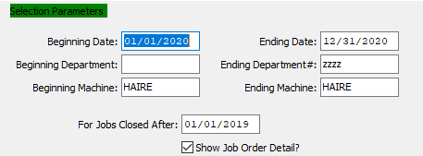

#### Beginning Date / Ending Date

Enter the beginning and ending Date to run the Labor Hours report for.

#### Beginning Department / Ending Department

Enter the beginning and ending Department Code to run the Labor Hours report for.

#### Beginning Machine / Ending Machine

Enter the beginning and ending machine Code to run the Labor Hours report for.

#### For Jobs Closed After

The date entered here will be the first date of the report. Any jobs scheduled after that date will be left off of the report.

#### Show Job Order Detail – Toggle Box

To show job order details on the report, make sure that this toggle box is checked.

### Available and Selected Columns

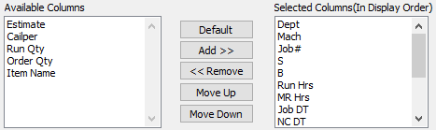

#### Available Columns

The user may choose which columns they wish to have on the report printout. As the user selects their choices, they will appear on the ‘*Selected Columns’* list.

#### Selected Columns (In Display Order)

The columns that the user has chosen from the ‘*Available Columns’* list. The order that these columns are displayed in here is the order in which they will print on the report.

#### Default

Click the ***“Default****”* button to sort the ‘*Selected Columns’* list by the default system parameters.

#### Add >>

Click on the selected item from the ‘*Available Columns’* list to highlight it, then click the ***“Add”*** button to add the selected column to the ‘*Selected Columns’* list.

#### << Remove

Click on the selected item from the ‘*Selected Columns’* list to highlight it, then click the ***“Remove”*** button to remove the selected column to the ‘*Selected Columns’* list.

#### Move Up

Within the ‘*Selected Columns’* list, the user may choose the order they wish the selected columns to print in. In order to change the order of the columns, the user can click on a selection to highlight it. By then clicking the ***“Move Up***” button, the user can change its position on the report.

#### Move Down

Within the ‘*Selected Columns’* list, the user may choose the order they wish the selected columns to print in. In order to change the order of the columns, the user can click on a selection to highlight it. By then clicking the ***“Move Down***” button, the user can change its position on the report.

### Output Destination

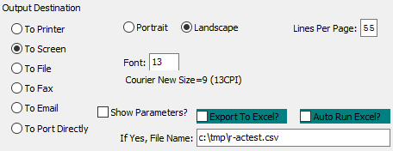

#### Destination Choice

To choose the destination where the document should be printed, please make sure that desired output destination choice bubble is toggled.

#### Layout Choice

To choose the preferred layout of Landscape vs. Portrait, please make sure the desired option choice bubbled is toggled.

#### Show Parameters? – Toggle Box

To show parameters, make sure that the toggle box is ‘ticked’ with a checkmark.

#### Export to Excel? – Toggle Box

To export the printed file to an excel document, make sure that the Export to Excel toggle box is checked.

#### Auto Run Excel? – Toggle Box

To automatically open the new excel document, make sure that the Auto Run Excel toggle box is checked.

## Labor Hours by Charge Code [DR7]

The labor hours by charge code sorts the date by machine charge code. This shows comparison of actual hours posted to production versus estimated standard hours without any run speed or waste reporting. The report is useful to see what machines are losing money, what machines may need to be replaced and also as a tool to upgrade your machine standards for make ready, run speeds and waste standards in the machine file. The [DR3] report provides more details per job number.

The print selection allows limited the report by machine department, machine code, product category and any date range and may be sorted by charge code or charge description. The report may be output computer screen, printer, fax, email or directly text file or to an excel format.

The *Labor Hours vs. Charge Code Report* screen is located in the following Menu Path: Data Collection -> Reports for Data Collection -> Labor Hours by Charge Code. Alternatively, the user can quickly get to this screen using the Hot Key combination: ***[“D” – “R” – “7”]***.

### Selection Parameters

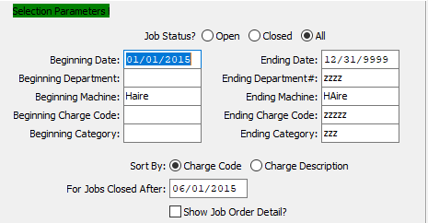

#### Job Status? (Choice)

To choose the preferred Job Status of Open vs. Closed (Or All), please make sure the desired option choice bubble is toggled.

#### Beginning Date / Ending Date

Enter the beginning and ending Date to run the Labor Hours report for.

#### Beginning Department / Ending Department

Enter the beginning and ending Department Code to run the Labor Hours report for.

#### Beginning Machine / Ending Machine

Enter the beginning and ending Machine Code to run the Labor Hours report for.

#### Beginning Charge Code / Ending Charge Code

Enter the beginning and ending Charge Code to run the Labor Hours report for.

#### Beginning Category / Ending Category

Enter the beginning and ending Category to run the Labor Hours report for.

#### Sort By (Choice)

To choose the preferred sorting method of Code vs. Description, please make sure the desired option choice bubble is toggled.

#### For Jobs Closed After

The date entered here will be the first date of the report. Any jobs scheduled after that date will be left off of the report.

#### Show Job Order Detail? – Toggle Box

To show job order detail on the Labor Hours report, make sure that this toggle box is checked.

### Available and Selected Columns

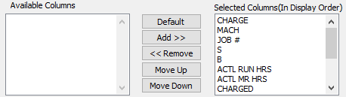

#### Available Columns

The user may choose which columns they wish to have on the report printout. As the user selects their choices, they will appear on the ‘*Selected Columns’* list.

#### Selected Columns (In Display Order)

The columns that the user has chosen from the ‘*Available Columns’* list. The order that these columns are displayed in here is the order in which they will print on the report.

#### Default

Click the ***“Default****”* button to sort the ‘*Selected Columns’* list by the default system parameters.

#### Add >>

Click on the selected item from the ‘*Available Columns’* list to highlight it, then click the ***“Add”*** button to add the selected column to the ‘*Selected Columns’* list.

#### << Remove

Click on the selected item from the ‘*Selected Columns’* list to highlight it, then click the ***“Remove”*** button to remove the selected column to the ‘*Selected Columns’* list.

#### Move Up

Within the ‘*Selected Columns’* list, the user may choose the order they wish the selected columns to print in. In order to change the order of the columns, the user can click on a selection to highlight it. By then clicking the ***“Move Up***” button, the user can change its position on the report.

#### Move Down

Within the ‘*Selected Columns’* list, the user may choose the order they wish the selected columns to print in. In order to change the order of the columns, the user can click on a selection to highlight it. By then clicking the ***“Move Down***” button, the user can change its position on the report.

### Output Destination

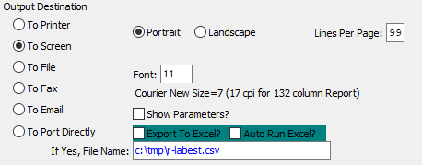

#### Destination Choice

To choose the destination where the document should be printed, please make sure that desired output destination choice bubble is toggled.

#### Layout Choice

To choose the preferred layout of Landscape vs. Portrait, please make sure the desired option choice bubbled is toggled.

#### Lines Per Page

Lines per page on the report when printing.

#### Font

Enter the font number to use with this report (Font 11 is default).

#### Show Parameters? – Toggle Box

To show parameters, make sure that the toggle box is ‘ticked’ with a checkmark.

#### Export to Excel? – Toggle Box

To export the printed file to an excel document, make sure that the Export to Excel toggle box is checked.

#### Auto Run Excel? – Toggle Box

To automatically open the new excel document, make sure that the Auto Run Excel toggle box is checked.

#### If Yes, File Name

If exporting the file to Excel, enter the desired file name.

## WIP Job Audit Trail [DR8]

The job audit trail is a history of all costs applied to the job including material, machine hours, waste and finished goods receipts.

The print selection allows limited the report by a range of job numbers. The report may be output computer screen, printer, fax, email or directly text file or to an excel format.

The *W.I.P. Posting Edit List* screen is located in the following Menu Path: Data Collection -> Reports for Data Collection -> WIP Job Audit Trail. Alternatively, the user can quickly get to this screen using the Hot Key combination: ***[“D” – “R” – “8”]***.

### Selection Parameters

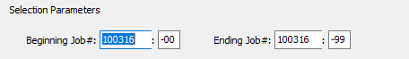

#### Beginning Job # / Ending Job #

Enter the beginning and ending Job Number to run the Job Audit report for.

#### Beginning Job #: 00 / Ending Job #: 00

Enter the beginning and ending Subsequent Job Number to run the Job Audit report for.

### Available and Selected Columns

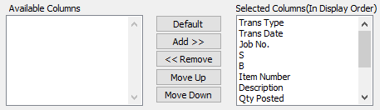

#### Available Columns

The user may choose which columns they wish to have on the report printout. As the user selects their choices, they will appear on the ‘*Selected Columns’* list.

#### Selected Columns (In Display Order)

The columns that the user has chosen from the ‘*Available Columns’* list. The order that these columns are displayed in here is the order in which they will print on the report.

#### Default

Click the ***“Default****”* button to sort the ‘*Selected Columns’* list by the default system parameters.

#### Add >>

Click on the selected item from the ‘*Available Columns’* list to highlight it, then click the ***“Add”*** button to add the selected column to the ‘*Selected Columns’* list.

#### << Remove

Click on the selected item from the ‘*Selected Columns’* list to highlight it, then click the ***“Remove”*** button to remove the selected column to the ‘*Selected Columns’* list.

#### Move Up

Within the ‘*Selected Columns’* list, the user may choose the order they wish the selected columns to print in. In order to change the order of the columns, the user can click on a selection to highlight it. By then clicking the ***“Move Up***” button, the user can change its position on the report.

#### Move Down

Within the ‘*Selected Columns’* list, the user may choose the order they wish the selected columns to print in. In order to change the order of the columns, the user can click on a selection to highlight it. By then clicking the ***“Move Down***” button, the user can change its position on the report.

### Output Destination

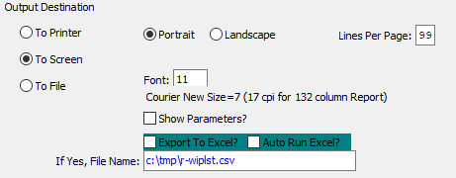

#### Destination Choice

To choose the destination where the document should be printed, please make sure that desired output destination choice bubble is toggled.

#### Layout Choice

To choose the preferred layout of Landscape vs. Portrait, please make sure the desired option choice bubbled is toggled.

#### Lines Per Page

Lines per page on the report when printing.

#### Font

Enter the font number to use with this report (Font 11 is default).

#### Show Parameters? – Toggle Box

To show parameters, make sure that the toggle box is ‘ticked’ with a checkmark.

#### Export to Excel? – Toggle Box

To export the printed file to an excel document, make sure that the Export to Excel toggle box is checked.

#### Auto Run Excel? – Toggle Box

To automatically open the new excel document, make sure that the Auto Run Excel toggle box is checked.

#### If Yes, File Name

If exporting the file to Excel, enter the desired file name.

## Materials Allocation [DR9]

The allocated materials requirements report provides a list of material shortages based on quantities that have been committed to jobs, not just on hand quantity.

The print selection allows limited the report by a range of job numbers. The report may be output computer screen, printer, fax, email or directly text file or to an excel format.

The *Allocated Materials Requirement Report* screen is located in the following Menu Path: Data Collection -> Reports for Data Collection -> Materials Allocation. Alternatively, the user can quickly get to this screen using the Hot Key combination: ***[“D” – “R” – “9”]***.

### Selection Parameters

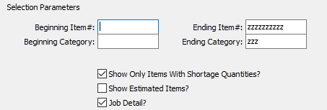

#### Beginning Item # / Ending Item #

Enter the beginning and ending Item Number to run the Materials Allocation report for.

#### Beginning Category / Ending Category

Enter the beginning and ending Category to run the Materials Allocation report for.

#### Show Only Items with Shortage Quantities? – Toggle Box

To only show items that have a shortage on the report, make sure that this toggle box is checked.

#### Show Estimated Items? – Toggle Box

To show estimated items on the report, make sure that the Show Estimated Items toggle box is checked.

#### Job Detail? – Toggle Box

To show job detail information on the report, make sure that the Job Detail toggle box is checked.

### Available and Selected Columns

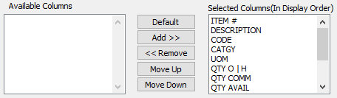

#### Available Columns

The user may choose which columns they wish to have on the report printout. As the user selects their choices, they will appear on the ‘*Selected Columns’* list.

#### Selected Columns (In Display Order)

The columns that the user has chosen from the ‘*Available Columns’* list. The order that these columns are displayed in here is the order in which they will print on the report.

#### Add >>

Click on the selected item from the ‘*Available Columns’* list to highlight it, then click the ***“Add”*** button to add the selected column to the ‘*Selected Columns’* list.

#### << Remove

Click on the selected item from the ‘*Selected Columns’* list to highlight it, then click the ***“Remove”*** button to remove the selected column to the ‘*Selected Columns’* list.

#### Move Up

Within the ‘*Selected Columns’* list, the user may choose the order they wish the selected columns to print in. In order to change the order of the columns, the user can click on a selection to highlight it. By then clicking the ***“Move Up***” button, the user can change its position on the report.

#### Move Down

Within the ‘*Selected Columns’* list, the user may choose the order they wish the selected columns to print in. In order to change the order of the columns, the user can click on a selection to highlight it. By then clicking the ***“Move Down***” button, the user can change its position on the report.

### Output Destination

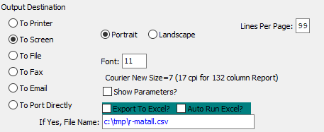

#### Destination Choice

To choose the destination where the document should be printed, please make sure that desired output destination choice bubble is toggled.

#### Layout Choice

To choose the preferred layout of Landscape vs. Portrait, please make sure the desired option choice bubbled is toggled.

#### Show Parameters? – Toggle Box

To show parameters, make sure that the toggle box is ‘ticked’ with a checkmark.

#### Export to Excel? – Toggle Box

To export the printed file to an excel document, make sure that the Export to Excel toggle box is checked.

#### Auto Run Excel? – Toggle Box

To automatically open the new excel document, make sure that the Auto Run Excel toggle box is checked.

## Open Jobs by Due Date/Customer [DR)]

The allocated materials requirements report provides a list of material shortages based on quantities that have been committed to jobs, not just on hand quantity.

The print selection allows limited the report by a range of customers and due dates. The report may be output computer screen, printer, fax, email or directly text file or to an excel format.

The *Open Jobs by Due Date* screen is located in the following Menu Path: Data Collection -> Reports for Data Collection -> Open Jobs by Due Date/Customer. Alternatively, the user can quickly get to this screen using the Hot Key combination: ***[“D” – “R” – “)”]***.

### Selection Parameters

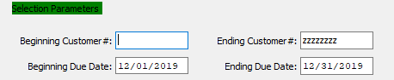

#### Beginning Customer # / Ending Customer #

Enter the beginning and ending Customer Number to run the Open Jobs report for.

#### Beginning Due Date / Ending Due Date

Enter the beginning and ending Due Date to run the Open Jobs report for.

### Available and Selected Columns

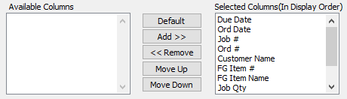

#### Available Columns

The user may choose which columns they wish to have on the report printout. As the user selects their choices, they will appear on the ‘*Selected Columns’* list.

#### Selected Columns (In Display Order)

The columns that the user has chosen from the ‘*Available Columns’* list. The order that these columns are displayed in here is the order in which they will print on the report.

#### Default

Click the ***“Default****”* button to sort the ‘*Selected Columns’* list by the default system parameters.

#### Add >>

Click on the selected item from the ‘*Available Columns’* list to highlight it, then click the ***“Add”*** button to add the selected column to the ‘*Selected Columns’* list.

#### << Remove

Click on the selected item from the ‘*Selected Columns’* list to highlight it, then click the ***“Remove”*** button to remove the selected column to the ‘*Selected Columns’* list.

#### Move Up

Within the ‘*Selected Columns’* list, the user may choose the order they wish the selected columns to print in. In order to change the order of the columns, the user can click on a selection to highlight it. By then clicking the ***“Move Up***” button, the user can change its position on the report.

#### Move Down

Within the ‘*Selected Columns’* list, the user may choose the order they wish the selected columns to print in. In order to change the order of the columns, the user can click on a selection to highlight it. By then clicking the ***“Move Down***” button, the user can change its position on the report.

### Output Destination

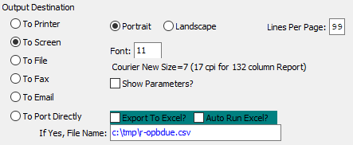

#### Destination Choice

To choose the destination where the document should be printed, please make sure that desired output destination choice bubble is toggled.

#### Layout Choice

To choose the preferred layout of Landscape vs. Portrait, please make sure the desired option choice bubbled is toggled.

#### Lines Per Page

Lines per page on the report when printing.

#### Font

Enter the font number to use with this report (Font 11 is default).

#### Show Parameters? – Toggle Box

To show parameters, make sure that the toggle box is ‘ticked’ with a checkmark.

#### Export to Excel? – Toggle Box

To export the printed file to an excel document, make sure that the Export to Excel toggle box is checked.

#### Auto Run Excel? – Toggle Box

To automatically open the new excel document, make sure that the Auto Run Excel toggle box is checked.

#### If Yes, File Name

If exporting the file to Excel, enter the desired file name.

## Scrap Report [DR!]

The scrap report by printing press provides a list of material shortages based on quantities that have been committed to jobs, not just on hand quantity.

The print selection allows limited the report by a range of jobs and dates. The report may be output computer screen, printer, fax, email or directly text file or to an excel format.

The *Scrap Report* screen is located in the following Menu Path: Data Collection -> Reports for Data Collection -> Scrap Report. Alternatively, the user can quickly get to this screen using the Hot Key combination: ***[“D” – “R” – “!”]***.

### Selection Parameters

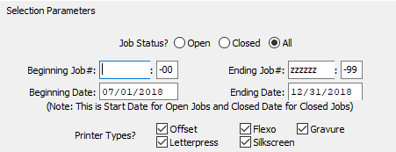

#### Job Status (Choice)

To choose the preferred Job Status of Open vs. Closed (Or All), please make sure the desired option choice bubble is toggled.

#### Beginning Job # / Ending Job #

Enter the beginning and ending Job Number to run the Scrap report for.

#### Beginning Job #: 00 / Ending Job #: 00

Enter the beginning and ending Subsequent Job Number to run the Scrap report for.

#### Beginning Date / Ending Date

Enter the beginning and ending Date to run the Scrap report for.

#### Printer Types: Offset – Toggle Box

To include Offset printer types in the Scrap report, make sure that this toggle box is checked.

#### Printer Types: Letterpress – Toggle Box

To include Letterpress printer types in the Scrap report, make sure that this toggle box is checked.

#### Printer Types: Flexo – Toggle Box

To include Flexo printer types in the Scrap report, make sure that this toggle box is checked.

#### Printer Types: Silkscreen – Toggle Box

To include Silkscreen printer types in the Scrap report, make sure that this toggle box is checked.

#### Printer Types: Gravure – Toggle Box

To include Gravure printer types in the Scrap report, make sure that this toggle box is checked.

### Available and Selected Columns

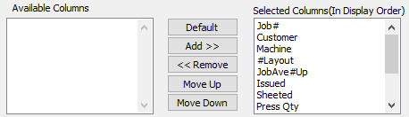

#### Available Columns

The user may choose which columns they wish to have on the report printout. As the user selects their choices, they will appear on the ‘*Selected Columns’* list.

#### Selected Columns (In Display Order)

The columns that the user has chosen from the ‘*Available Columns’* list. The order that these columns are displayed in here is the order in which they will print on the report.

#### Default

Click the ***“Default****”* button to sort the ‘*Selected Columns’* list by the default system parameters.

#### Add >>

Click on the selected item from the ‘*Available Columns’* list to highlight it, then click the ***“Add”*** button to add the selected column to the ‘*Selected Columns’* list.

#### << Remove

Click on the selected item from the ‘*Selected Columns’* list to highlight it, then click the ***“Remove”*** button to remove the selected column to the ‘*Selected Columns’* list.

#### Move Up

Within the ‘*Selected Columns’* list, the user may choose the order they wish the selected columns to print in. In order to change the order of the columns, the user can click on a selection to highlight it. By then clicking the ***“Move Up***” button, the user can change its position on the report.

#### Move Down

Within the ‘*Selected Columns’* list, the user may choose the order they wish the selected columns to print in. In order to change the order of the columns, the user can click on a selection to highlight it. By then clicking the ***“Move Down***” button, the user can change its position on the report.

### Output Destination

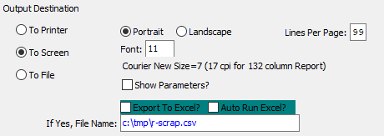

#### Destination Choice

To choose the destination where the document should be printed, please make sure that desired output destination choice bubble is toggled.

#### Layout Choice

To choose the preferred layout of Landscape vs. Portrait, please make sure the desired option choice bubbled is toggled.

#### Lines Per Page

Lines per page on the report when printing.

#### Font

Enter the font number to use with this report (Font 11 is default).

#### Show Parameters? – Toggle Box

To show parameters, make sure that the toggle box is ‘ticked’ with a checkmark.

#### Export to Excel? – Toggle Box

To export the printed file to an excel document, make sure that the Export to Excel toggle box is checked.

#### Auto Run Excel? – Toggle Box

To automatically open the new excel document, make sure that the Auto Run Excel toggle box is checked.

#### If Yes, File Name

If exporting the file to Excel, enter the desired file name.

## Scrap Report by Machine [DR@]

The scrap report by machine provides comparison of sheets issued to the job versus the total of finished goods produced. The system converts the number of on a sheet into the number of finished boxes to determine the waste variances.

The print selection limits the report to open, closed or all jobs and also limits the report by a range of machines, shifts and dates. The report may be output computer screen, printer, fax, email or directly text file or to an excel format.

The *Scrap Report* screen is located in the following Menu Path: Data Collection -> Reports for Data Collection -> Scrap Report by Machine. Alternatively, the user can quickly get to this screen using the Hot Key combination: ***[“D” – “R” – “@”]***.

### Selection Parameters

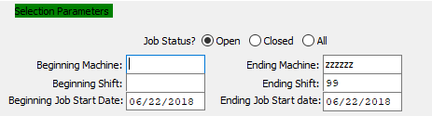

#### Job Status? (Choice)

To choose the preferred Job Status of Open vs. Closed (Or All), please make sure the desired option choice bubble is toggled.

#### Beginning Machine / Ending Machine

Enter the beginning and ending Machine Code to run the Scrap by Machine report for.

#### Beginning Shift / Ending Shift

Enter the beginning and ending Shift Number to run the Scrap by Machine report for.

#### Beginning Job Start Date / Ending Job Start Date

Enter the beginning and ending Job Start Date to run the Scrap by Machine report for.

### Available and Selected Columns

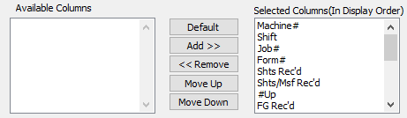

#### Available Columns

The user may choose which columns they wish to have on the report printout. As the user selects their choices, they will appear on the ‘*Selected Columns’* list.

#### Selected Columns (In Display Order)

The columns that the user has chosen from the ‘*Available Columns’* list. The order that these columns are displayed in here is the order in which they will print on the report.

#### Default

Click the ***“Default****”* button to sort the ‘*Selected Columns’* list by the default system parameters.

#### Add >>

Click on the selected item from the ‘*Available Columns’* list to highlight it, then click the ***“Add”*** button to add the selected column to the ‘*Selected Columns’* list.

#### << Remove

Click on the selected item from the ‘*Selected Columns’* list to highlight it, then click the ***“Remove”*** button to remove the selected column to the ‘*Selected Columns’* list.

#### Move Up

Within the ‘*Selected Columns’* list, the user may choose the order they wish the selected columns to print in. In order to change the order of the columns, the user can click on a selection to highlight it. By then clicking the ***“Move Up***” button, the user can change its position on the report.

#### Move Down

Within the ‘*Selected Columns’* list, the user may choose the order they wish the selected columns to print in. In order to change the order of the columns, the user can click on a selection to highlight it. By then clicking the ***“Move Down***” button, the user can change its position on the report.

### Output Destination

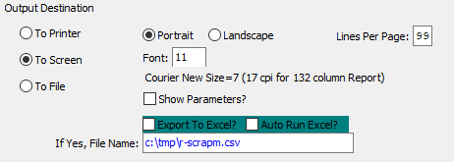

#### Destination Choice

To choose the destination where the document should be printed, please make sure that desired output destination choice bubble is toggled.

#### Layout Choice

To choose the preferred layout of Landscape vs. Portrait, please make sure the desired option choice bubbled is toggled.

#### Show Parameters? – Toggle Box

To show parameters, make sure that the toggle box is ‘ticked’ with a checkmark.

#### Export to Excel? – Toggle Box

To export the printed file to an excel document, make sure that the Export to Excel toggle box is checked.

#### Auto Run Excel? – Toggle Box

To automatically open the new excel document, make sure that the Auto Run Excel toggle box is checked.

## Machine Backlog by Kicks [DR#]

The machine backlog report shows machine backlog represented by kicks, which is the same as impressions or sheets. This is printed up to a specific date, while printing the details of each job for the day including hours required and hours remaining.

The visual scheduling software provides far greater visual and reporting options, but this report can be used when the scheduling module is not purchased.

The print selection allows limited the report by machine department, machine code up to a specific start date or due date. The report also has an option to print either the machine description or customer name. The report may be output computer screen, printer, fax, email or directly text file or to an excel format.

The *Machine Backlog by Kicks* screen is located in the following Menu Path: Data Collection -> Reports for Data Collection -> Machine Backlog by Kicks. Alternatively, the user can quickly get to this screen using the Hot Key combination: ***[“D” – “R” – “#”]***.

### Selection Parameters

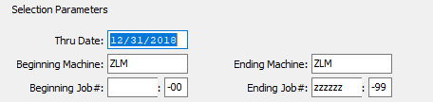

#### Thru Date

The date entered here will be the last date of the report. Any jobs scheduled after that date will be left off of the report.

#### Beginning Machine / Ending Machine

Enter the beginning and ending Machine Code to run the Backlog report for.

#### Beginning Job # / Ending Job #

Enter the beginning and ending Job Number to run the Backlog report for.

#### Beginning Job #: 00 / Ending Job #: 00

Enter the beginning and ending Subsequent Job Number to run the Backlog report for.

### Available and Selected Columns

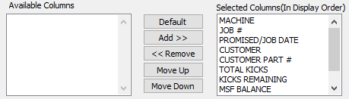

#### Available Columns

The user may choose which columns they wish to have on the report printout. As the user selects their choices, they will appear on the ‘*Selected Columns’* list.

#### Selected Columns (In Display Order)

The columns that the user has chosen from the ‘*Available Columns’* list. The order that these columns are displayed in here is the order in which they will print on the report.

#### Default

Click the ***“Default****”* button to sort the ‘*Selected Columns’* list by the default system parameters.

#### Add >>

Click on the selected item from the ‘*Available Columns’* list to highlight it, then click the ***“Add”*** button to add the selected column to the ‘*Selected Columns’* list.

#### << Remove

Click on the selected item from the ‘*Selected Columns’* list to highlight it, then click the ***“Remove”*** button to remove the selected column to the ‘*Selected Columns’* list.

#### Move Up

Within the ‘*Selected Columns’* list, the user may choose the order they wish the selected columns to print in. In order to change the order of the columns, the user can click on a selection to highlight it. By then clicking the ***“Move Up***” button, the user can change its position on the report.

#### Move Down

Within the ‘*Selected Columns’* list, the user may choose the order they wish the selected columns to print in. In order to change the order of the columns, the user can click on a selection to highlight it. By then clicking the ***“Move Down***” button, the user can change its position on the report.

### Output Destination

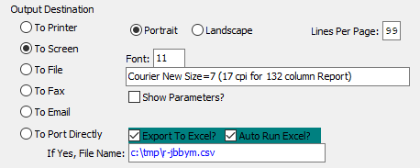

#### Destination Choice

To choose the destination where the document should be printed, please make sure that desired output destination choice bubble is toggled.

#### Layout Choice

To choose the preferred layout of Landscape vs. Portrait, please make sure the desired option choice bubbled is toggled.

#### Lines Per Page

Lines per page on the report when printing.

#### Font

Enter the font number to use with this report (Font 11 is default).

#### Show Parameters? – Toggle Box

To show parameters, make sure that the toggle box is ‘ticked’ with a checkmark.

#### Export to Excel? – Toggle Box

To export the printed file to an excel document, make sure that the Export to Excel toggle box is checked.

#### Auto Run Excel? – Toggle Box

To automatically open the new excel document, make sure that the Auto Run Excel toggle box is checked.

#### If Yes, File Name

If exporting the file to Excel, enter the desired file name.

## WIP Standards Detail [DR$]

The *WIP Standards Detail Report* screen is located in the following Menu Path: Data Collection -> Reports for Data Collection -> WIP Standard Detail. Alternatively, the user can quickly get to this screen using the Hot Key combination: ***[“D” – “R” – “$”]***.

### Selection Parameters

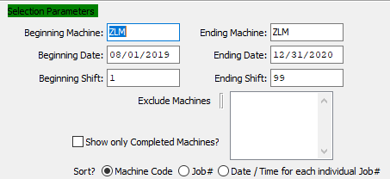

#### Beginning Machine / Ending Machine

Enter the beginning and ending Machine Code to run the Work in Process Standards Detailed report for.

#### Beginning Date / Ending Date

Enter the beginning and ending Date to run the Work in Process Standards Detailed report for.

#### Beginning Shift / Ending Shift

Enter the beginning and ending Shift Number to run the Work in Process Standards Detailed report for.

#### Exclude Machines

The user may select which Machines they wish to exclude from the current Detail Report. To select multiple Machines, press the ***“Control”*** button while clicking the desired Machine within the available Machine list. Selected Machines will be highlighted, and only highlighted Machines will be excluded from the Detail Report. To deselect Machines, press the ***“Control”*** button while clicking already-highlighted selections.

#### Show Only Completed Machines? – Toggle Box

To only show completed machines in the detail report, make sure that this toggle box is checked.

#### Sort? (Choice)

To choose the preferred sorting method, please make sure the desired option choice bubble is toggled.

### Available and Selected Columns

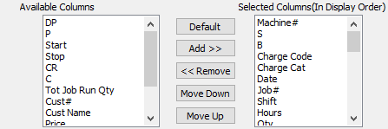

#### Available Columns

The user may choose which columns they wish to have on the report printout. As the user selects their choices, they will appear on the ‘*Selected Columns’* list.

#### Selected Columns (In Display Order)

The columns that the user has chosen from the ‘*Available Columns’* list. The order that these columns are displayed in here is the order in which they will print on the report.

#### Default

Click the ***“Default****”* button to sort the ‘*Selected Columns’* list by the default system parameters.

#### Add >>

Click on the selected item from the ‘*Available Columns’* list to highlight it, then click the ***“Add”*** button to add the selected column to the ‘*Selected Columns’* list.

#### << Remove

Click on the selected item from the ‘*Selected Columns’* list to highlight it, then click the ***“Remove”*** button to remove the selected column to the ‘*Selected Columns’* list.

#### Move Up

Within the ‘*Selected Columns’* list, the user may choose the order they wish the selected columns to print in. In order to change the order of the columns, the user can click on a selection to highlight it. By then clicking the ***“Move Up***” button, the user can change its position on the report.

#### Move Down

Within the ‘*Selected Columns’* list, the user may choose the order they wish the selected columns to print in. In order to change the order of the columns, the user can click on a selection to highlight it. By then clicking the ***“Move Down***” button, the user can change its position on the report.

### Output Destination

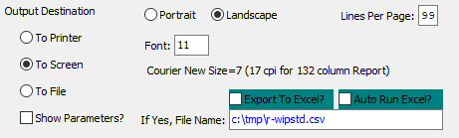

#### Destination Choice

To choose the destination where the document should be printed, please make sure that desired output destination choice bubble is toggled.

#### Layout Choice

To choose the preferred layout of Landscape vs. Portrait, please make sure the desired option choice bubbled is toggled.

#### Lines Per Page

Lines per page on the report when printing.

#### Font

Enter the font number to use with this report (Font 11 is default).

#### Show Parameters? – Toggle Box

To show parameters, make sure that the toggle box is ‘ticked’ with a checkmark.

#### Export to Excel? – Toggle Box

To export the printed file to an excel document, make sure that the Export to Excel toggle box is checked.

#### Auto Run Excel? – Toggle Box

To automatically open the new excel document, make sure that the Auto Run Excel toggle box is checked.

#### If Yes, File Name

If exporting the file to Excel, enter the desired file name.

## On-Time Deliveries for Jobs [DR%]

The *On-Time Deliveries for Jobs* screen is located in the following Menu Path: Data Collection -> Reports for Data Collection -> On-Time Deliveries for Jobs. Alternatively, the user can quickly get to this screen using the Hot Key combination: ***[“D” – “R” – “%”]***.

This report determines if the job was produced on time and does not consider time of shipment. This report will print Order Date, Production Time = Due Date - Order Date.

This report will look at projected days to produce the jobs versus the actual receipt date as the production date. On time is fully received prior to due date. Thereafter the job is considered late. The report will search all orders and jobs, not dependent on if it is open or closed.

To determine if the item shipped on time, run the ***“O”-“R”-“$”*** on time delivery report. The report may be sent directly to excel.

### Selection Parameters

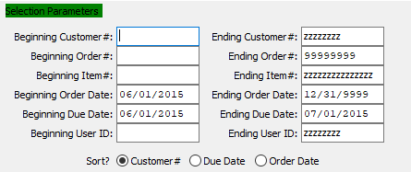

#### Beginning Customer # / Ending Customer #

Enter the beginning and ending Customer Number to run the Deliveries report for.

#### Beginning Order # / Ending Order #

Enter the beginning and ending Order Number to run the Deliveries report for.

#### Beginning Item # / Ending Item #

Enter the beginning and ending Item Number to run the Deliveries report for.

#### Beginning Order Date / Ending Order Date

Enter the beginning and ending Order Date to run the Deliveries report for.

#### Beginning Due Date / Ending Due Date

Enter the beginning and ending Due Date to run the Deliveries report for.

#### Beginning User ID / Ending User ID

Enter the beginning and ending User ID to run the Deliveries report for.

#### Sort? (Choice)

To choose the preferred sorting method, please make sure the desired option choice bubble is toggled.

### Available and Selected Columns

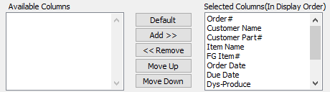

#### Available Columns

The user may choose which columns they wish to have on the report printout. As the user selects their choices, they will appear on the ‘*Selected Columns’* list.

#### Selected Columns (In Display Order)

The columns that the user has chosen from the ‘*Available Columns’* list. The order that these columns are displayed in here is the order in which they will print on the report.

#### Default

Click the ***“Default****”* button to sort the ‘*Selected Columns’* list by the default system parameters.

#### Add >>

Click on the selected item from the ‘*Available Columns’* list to highlight it, then click the ***“Add”*** button to add the selected column to the ‘*Selected Columns’* list.

#### << Remove

Click on the selected item from the ‘*Selected Columns’* list to highlight it, then click the ***“Remove”*** button to remove the selected column to the ‘*Selected Columns’* list.

#### Move Up

Within the ‘*Selected Columns’* list, the user may choose the order they wish the selected columns to print in. In order to change the order of the columns, the user can click on a selection to highlight it. By then clicking the ***“Move Up***” button, the user can change its position on the report.

#### Move Down

Within the ‘*Selected Columns’* list, the user may choose the order they wish the selected columns to print in. In order to change the order of the columns, the user can click on a selection to highlight it. By then clicking the ***“Move Down***” button, the user can change its position on the report.

### Output Destination

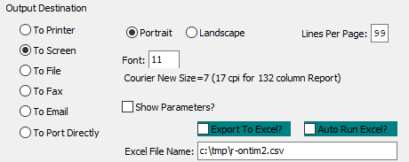

#### Destination Choice

To choose the destination where the document should be printed, please make sure that desired output destination choice bubble is toggled.

#### Layout Choice

To choose the preferred layout of Landscape vs. Portrait, please make sure the desired option choice bubbled is toggled.

#### Lines Per Page

Lines per page on the report when printing.

#### Font

Enter the font number to use with this report (Font 11 is default).

#### Show Parameters? – Toggle Box

To show parameters, make sure that the toggle box is ‘ticked’ with a checkmark.

#### Export to Excel? – Toggle Box

To export the printed file to an excel document, make sure that the Export to Excel toggle box is checked.

#### Auto Run Excel? – Toggle Box

To automatically open the new excel document, make sure that the Auto Run Excel toggle box is checked.

#### If Yes, File Name

If exporting the file to Excel, enter the desired file name.

# **Excel Reports [DE]**

## Machine Efficiency [DE1]

The *New Machine Efficiency Report (Excel)* screen is located in the following Menu Path: Data Collection -> Excel Reports -> Machine Efficiency - Excel. Alternatively, the user can quickly get to this screen using the Hot Key combination: ***[“D” – “E” – “1”]***.

### Selection Parameters

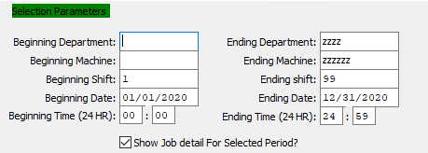

#### Beginning Department / Ending Department

Enter the beginning and ending Department to run the Machine Efficiency Report for.

#### Beginning Machine / Ending Machine

Enter the beginning and ending Machine Code to run the Machine Efficiency Report for.

#### Beginning Shift / Ending Shift

Enter the beginning and ending Shift Number to run the Machine Efficiency Report for.

#### Beginning Date / Ending Date

Enter the beginning and ending Date to run the Machine Efficiency Report for.

#### Beginning Time (24 HR) / Ending Time (24 HR)

Enter the beginning and ending Time to run the Machine Efficiency Report for.

#### Show Job Detail for Selected Period? – Toggle Box

To show detail information on the Machine Efficiency Report, make sure that this toggle box is checked.

### Output Destination

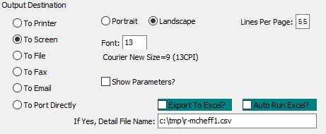

#### Destination Choice

To choose the destination where the document should be printed, please make sure that desired output destination choice bubble is toggled.

#### Layout Choice

To choose the preferred layout of Landscape vs. Portrait, please make sure the desired option choice bubbled is toggled.

#### Lines Per Page

Lines per page on the report when printing.

#### Font

Enter the font number to use with this report (Font 11 is default).

#### Show Parameters? – Toggle Box

To show parameters, make sure that the toggle box is ‘ticked’ with a checkmark.

#### Export to Excel? – Toggle Box

To export the printed file to an excel document, make sure that the Export to Excel toggle box is checked.

#### Auto Run Excel? – Toggle Box

To automatically open the new excel document, make sure that the Auto Run Excel toggle box is checked.

#### If Yes, File Name

If exporting the file to Excel, enter the desired file name.

## Production Analysis [DE2]

The *Production Analysis* screen is located in the following Menu Path: Data Collection -> Excel Reports -> Production Analysis. Alternatively, the user can quickly get to this screen using the Hot Key combination: ***[“D” – “E” – “2”]***.

### Selection Parameters

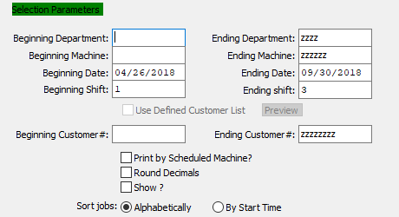

#### Beginning Department / Ending Department

Enter the beginning and ending Department to run the Production Analysis report for.

#### Beginning Machine / Ending Machine

Enter the beginning and ending Machine Code to run the Production Analysis report for.

#### Beginning Date / Ending Date

Enter the beginning and ending Date to run the Production Analysis report for.

#### Beginning Shift / Ending Shift

Enter the beginning and ending Shift Number to run the Production Analysis report for.

#### Use Defined Customer List – Toggle Box

To use a pre-defined customer list, make sure that this toggle box is checked.

#### Beginning Customer # / Ending Customer #

Enter the beginning and ending Customer Number to run the Production Analysis report for.

#### Print by Scheduled Machine? – Toggle Box

To print the report by scheduled machine, make sure that this toggle box is checked.

#### Round Decimals – Toggle Box

To round all hour count decimals within the selected parameters, make sure that the Round Decimals toggle box is checked.

#### Show? – Toggle Box

To show hour count decimals on the report, make sure that the Show toggle box is checked.

#### Sort Jobs (Choice)

To choose the preferred sorting method of Alphabetically vs. By Start Time, please make sure the desired option choice bubble is toggled.